World History
Learning Objectives

Unit 1 - Democratic Foundations
Prologue: Sections 1 - The Rise of Democratic Ideas

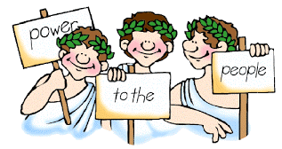

I. THE LEGACY OF ANCIENT GREECE AND ROME

A. Athens Builds a Limited Democracy

1. What is a government?

2. Who rules at the head of a monarchy?

3. What is the difference between an aristocracy and an oligarchy?

4. Who rules in a democracy?

B. Greek Democracy Changes

- What 2 assumptions did Greek thinkers base their philosophy on?

- What is Socrates’s “question and answer” approach called?

- Look at the pictures on page 9, what process are the pictures showing?

C. Rome Develops a Republic.

1. How is a republic different from a direct democracy?

2. Who were the patricians and the plebeians?

- What did the Twelve Tables establish?

4. Look at the illustration on page 11. What is it? What is the person doing?

